Dexels Navajo: Building the Information Hyperspace

Introduction

The Navajo framework enables the development of pure (web) service centric applications. The web service paradigm has come into existence due to an extended information demand which exceeds the possibilities of a web browser. In the web service world, information is not presented directly from a web server to a web browser, but instead information hubs are introduced in that share information between each other based upon the principle of best-of-breed delegation and as such creating an Information Hyperspace. Note that in this context information should be interpreted not only as read-only, but instead also something that can perform a function. An example of an information hub is shown in the figure below. An information hub, is an application that uses information for performing a specific function from another information hub; for example a reimbursement function fetches a distance between two zip codes from a hub that supplies a distance calculation function, in order to calculate the travel expenses. Another example of an information hub is the well known human information web's web server. Information endpoints can be anything from web browsers (HTML/Ajax) to more advanced client applications. The strength of the Navajo framework is that it supports both the optimal connectivity between information endpoints as well as between information hubs. The Navajo framework is used to create an information hub. Besides communication with other information hubs and information end points, an information hub may encapsulate information resources (like databases, reporting tools or any other application). Encapsulation is an important abstraction principle that is used to create implementation neutral web services.

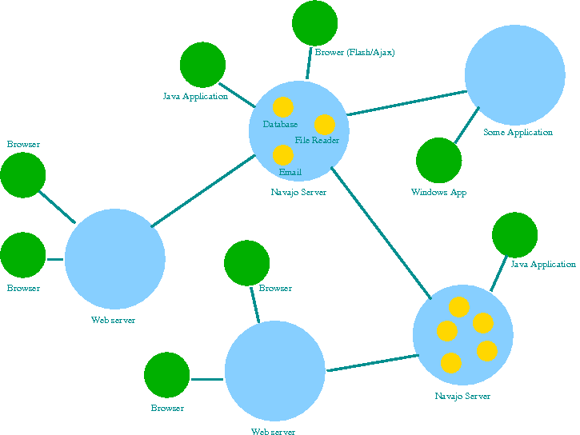Fig. 1: Information hyperspace: Information hubs (blue), end points (green) and resources (gold)

Data transformation

An XML based service definition language (TSL script) is used to process an XML request and produce an XML response. The TSL script is not interpreted, instead it is transformed into Java for fast execution by a standard Java JRE. The script language can be considered as a bi-directional data transformation definition between the static XML world and data represented in the dynamic Java world. Because, in turn, the Java world can encapsulate almost any other world, a Navajo service can transform XML data to and from any other data form. The Navajo framework includes a number of predefined, so called adapters, to easily support the data transformation task. An incomplete list of standard adapters include:

- JDBC/SQL database adapter
- File access adapter to access for example comma separated file data
- Email adapter to compose and read(!) email content
- XML adapter to manipulate XML based content
- HTTP adapter to connect to HTTP based services.
- FTP adapter to access data via FTP
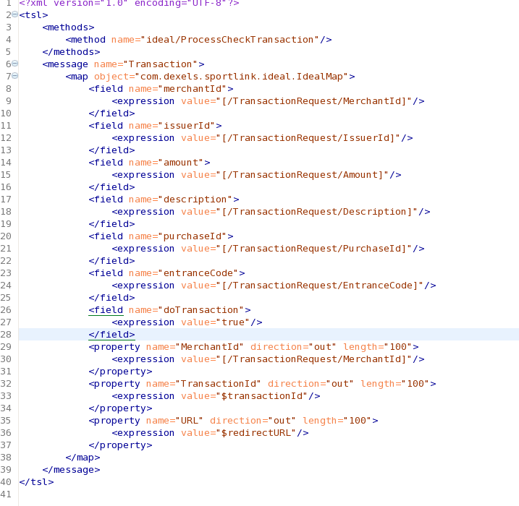Fig. 2: Example Navajo script for processing an Ideal payment request

Since all adapters are written in Java, the adapter library can be easily extended.

The Navajo XML definition supports binary data, hence any electronic document or image can be used in a Navajo service conversation.

Protocol listening

The Navajo Framework is not just another SOAP implementation instead it is a runtime environment for service oriented applications. Since Navajo is decoupled from the protocol listener layers, any protocol listener can be used to access the Navajo framework.
The standard edition supports communication protocols like the SOAP/HTTP-POST protocol but also a more lean native XML/HTTP-POST protocol and even an HTTP-GET URL based protocol. For simple XML structures Navajo web services can be accessed via URL encoding.
For secure data access the HTTPS protocol is supported.

Framework services

The framework supports a number of important services to provide a secure, scalable, reliable and high performance execution environment for the web services. These services include:

Navajo dashboard
A dashboard application is available to introspect and control a Navajo server. The dashboard applications shows information about currently running web services, scheduled tasks, fault/error reports, etc.

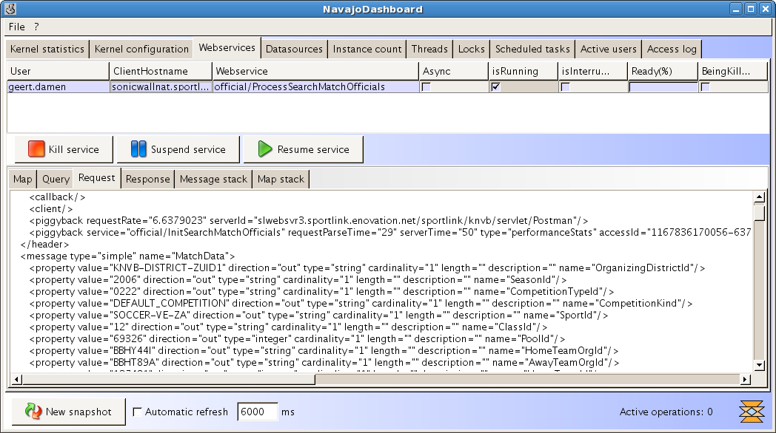Fig. 3: The dashboard showing a running web service and its request data

Flexible pluggable authentication/authorisation including support for digital certificates
Authentication and authorisation is decoupled from the Navajo kernel and as consequence can be easily adapted to implement any required authentication/authorisation scheme. A default SQL table based authentication/authorisation module is supplied.

Idempotent web service requests
Since a web service call can be performed over a potentially unreliable communication network a retry or duplicate request mechanism can be implemented by the calling party (client) to support a graceful execution on the site of the client in case of communication faults. As a consequence a web service can potentially be called multiple time by a client possibly causing unwanted data integrity artefacts. Therefore the Navajo kernel implements a short term web services request/response memory to detect multiple call and solving the integrity issue by either sending a previously stored response or by coupling a new request to a pending request.

Asynchronous web services.
By default Navajo web services are stateless. In other words a web service transaction does only need to be known by the server while it is being processed, after the response has been send the transaction is 'forgotten', state is therefore kept entirely on the client. Stateful transactions can be useful sometimes for example to implement asynchronous execution. Asynchronous execution can be very useful for long running processes. Therefore the Navajo kernel support asynchronous execution semantics in the scripts and an asynchronous process pool. An asynchronous process can be referenced by a unique id to either query its running or final status.

Monitoring
Each web service call can be registered for monitoring purposes. Furthermore, for easy error/exception solving a full request/response log is used.

Web service scheduling
Web services can be scheduled as a batch service on for example an hourly or daily basis.

Hot compiled Navajo service scripts
Whenever a Navajo script is changed, the server detects the change and will compile the script into a new Java class to enable fast execution and very flexible deployment of new or altered functions. Furthermore, beta versions of scripts can be deployed such that they can already be tested on a production environment without interference with a current version.

User interface integration

Besides server to server integration, where the calling party is itself a server application, a common use of web services is directly by client side applications. The Navajo server framework is complemented by a user interface (UI) framework that integrates efficiently with the Navajo services. This UI framework is named Navajo Tipi. A UI is defined in the Tipi XML language for seamless integration of Navajo web services and user interface components like buttons, labels, input fields, tables, etc. The Tipi framework is build in Java but it is GUI technology neutral, which means for example that it does not automatically imply that a Tipi application is a Java Swing Application. There is in fact a Java Swing Tipi implementation, but also an Ajax/DHTML based version. There is even a Flash implementation for Tipi. This is one of the big advantages of Tipi: it enables true single source multiple UI platform based client side application development.

Eclipse framework integration

Navajo web services can be written using anything from a text editor to special XML editors and can be tested on for example some J2EE application server; in fact, this is a feasible set up, since learning to write Navajo web services is remarkably quite easy. However, to support even better integration with for example Java development a Navajo web service Eclipse plug-in is available to build and test web services with even less effort. The Eclipse platform is the leading Integrated Development Environment (IDE) platform.
Eclipse 'views' are available to locally test developed web services within the Eclipse environment. Also, a similar tool is available to use web services that have been deployed on a remote server.

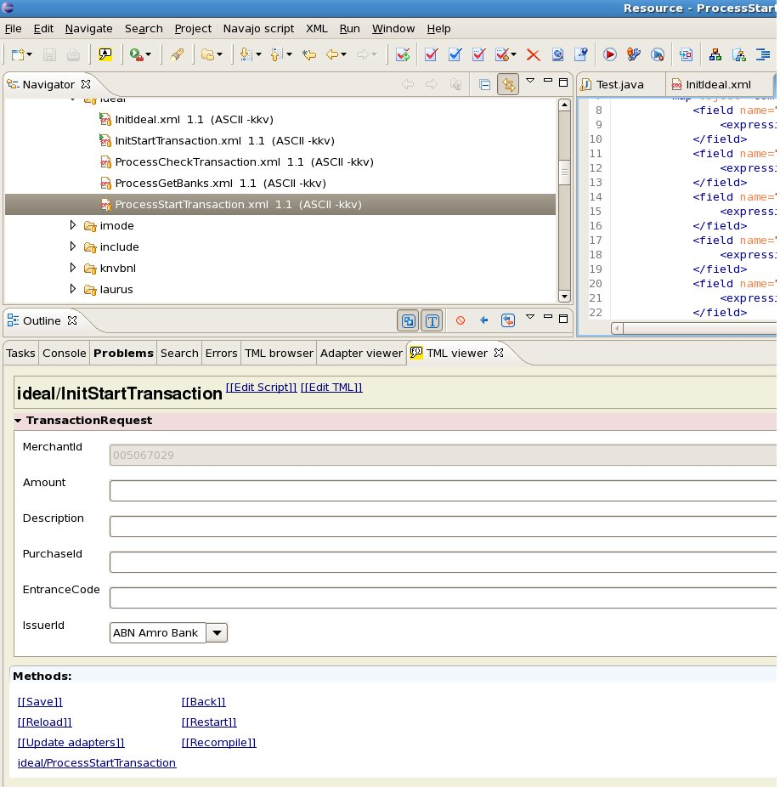Fig. 2: Running a web service from Eclipse
Web service documentation

'Documentation is an important part in software development'. This is a very true statement which anybody will definitely acknowledge. However, documentation is often sacrificed if the a project's dead line is rapidly approaching. Therefore, a documentation tool has been developed to simplify exactly this process. Using an XSLT transformation, HTML documentation can be generated swiftly from a set of web service scripts.

